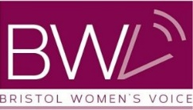

Report Author: Marnie Woodmeade
Bristol Women’s Voice
July 2021
Bangladeshi Women’s Health Project - Evaluation Report
Bangladeshi Women’s Health Project- Evaluation Report

Contents
Executive summary 2
Introduction 3
What the BWHP expected to do 3
Initial survey 4
What they did 5
Community Facilitator Model 5
Workshops 5
WhatsApp Group and Resource Library 6
Gardening Club 7
Celebration Picnic 7
Partnership with Bangladeshi Women’s Group 7
What difference did the BWHP make 8
Methodology 8
Demographics 8
Midway evaluation 8
Community Facilitator Model 10
Overall Outcomes 10
Workshop Outcomes 11
WhatsApp Chat Outcomes 12
Gardening Project Outcomes 14
Celebration Picnic 16
Challenges and changes 17
Future areas for development 18
Recommendations 19
Conclusion 19
References 20

Executive summary
The Bangladeshi Women’s Health Project (BWHP) was developed in response to the worsening health outcomes Bangladeshi women in Bristol experience and aimed to improve their knowledge and confidence with a variety of health issues. The City Listening Project - previous research done by Bristol Women’s Voice that used community partnerships and trained researchers from these partner organisations - highlighted the issues that Bangladeshi women have been facing with menopause, exercise and caring for SEN children. The City Listening Project also laid the foundation for a partnership with the Bangladeshi Women’s Group, alongside demonstrating the effectiveness of using a community development model in which women are trained to reach out and support other members of their community. The BWHP aimed to hire two community facilitators who would be trained to carry out the project.
The BWHP initially got off to a slow start as the project coordinator struggled to re-establish the connection with the Bangladeshi Women’s Group and as a result finding suitable community facilitators was difficult. However, once the community facilitators had been found and the partnership with BWG was revamped the project started to gain momentum. An initial survey and interviews conducted by the community facilitators and project coordinator demonstrated the extent of the problems that Bangladeshi women were facing and asked how they would like the project to run, and what issues to focus on.
The project had three crucial elements: online workshops that specifically addressed the issues raised in the survey, a WhatsApp group to share health information and provide support for women facing health issues and a gardening project that was supported by a donation drive across Bristol and a smaller WhatsApp group where women could share their experiences. The combination of these elements combined to provide Bangladeshi women with opportunities to increase their knowledge of health issues such as menopause, breast cancer awareness and mental health while also providing a space to ask questions and share messages of support. The women who partook in the project have reported an increased knowledge of the health issues covered and have spoken about the increased motivation they feel within their community to tackle these issues.
The project had to change drastically to be entirely online due to COVID-19 restrictions. On the one hand, this proved to be quite a big strength as women could partake in the project at times suitable to them or join workshops while cooking or providing childcare. However, this meant that some women were not reached by the project due to digital isolation and future projects should investigate how to reach those women.

Introduction
The Bangladeshi Women’s Health Project was developed in response to the results of the City Listening Project that highlighted that women’s health issues were of increasing concern, particularly in relation to menopause and mental health. Furthermore, the British Medical Association have highlighted that Bangladeshi people have a higher risk of coronary heart disease, diabetes and mental ill health (McKeigue et al 1988; Raleigh & Holmes 2021). Bangladeshi women only take 11% of the daily recommended amount of exercise (McNally 2015). This project aimed to address these issues through a model of not just providing information but also opportunities for training and development. BWV has worked extensively in economically deprived areas of the city and has seen a clear connection between isolation, lack of skills and employment and poor health outcomes.
Therefore, this was not just a project to improve knowledge surrounding health but also confidence in themselves and increased social networks both within and outside of the Bangladeshi community. Furthermore, in order to ensure the success and sustainability of the project, BWV wanted to develop a stronger partnership with the Bangladeshi Women’s Group and compliment their work sending out health messages, alongside utilising BWV connections with women’s health services so that connections could also be built on an organisational level.

What the BWHP expected to do
The overall aim of the project was to improve health and wellbeing, alongside building skills, confidence, and social networks. The BWHP proposed to achieve this by providing 50 Bangladeshi women with health information that was more directly relevant in a format that met their needs and by meeting 5 women each month through one-one contacts or group sessions. This was a pilot project for the community facilitator model, so BWV proposed to hire two community facilitators who would learn new skills including how to train the trainers and pass these on to other women while also helping to facilitate workshops and information sharing.
In order to build social networks, a self-help group within the project was established to support women within and outside their communities. Initially, this was planned to be in person, but due to the COVID-19 restrictions, this had to be fully online. BWV wanted the self-help group to not just be a place to gain information but also where they could socialise and support one another. Workshops about a variety of health issues would also serve the double purpose of increasing women’s knowledge while tackling isolation and providing safe spaces for women.
As a result of the workshops, self-help group and support from the community facilitators the BWHP hoped that women would feel more empowered to raise issues with GPs and other agencies and be able to identify and present requirements to agencies. BWV also hoped that this would open more communication with service providers, as they have previously reported that they have struggled to engage with Bangladeshi women. As a result of this, service providers would not only be able to directly communicate healthcare messages with Bangladeshi women but also provide them with services that meet their needs and are more culturally appropriate.

Initial survey
In order to ensure the project was grounded in evidence about how Bangladeshi women in Bristol wanted health issues to be addressed and which issues in particular they required more information on, the first month of Community Facilitator time was spent on speaking to women in their community and filling out an initial survey. 53 women filled out the survey, many of whom were from parts of the community that healthcare services were not accessing, such as those with poor English or low levels of confidence in accessing health care. They were helped by the community facilitators or members of their household to contribute. However, due to the COVID restrictions at the time, the community facilitators were unable to do any face-to-face consultation and therefore digitally excluded women were not included as part of the sample, particularly if they did not have friends or relatives with access to a computer or smartphone.
The initial survey demonstrated that women were very concerned about their health, as when asked to rank their concern on a scale of 1-10, 52% of women ranked themselves 8 or higher and none of the women who participated scored themselves as a 1. Furthermore, when asked which services they had difficulty accessing, 25% said they struggled to get a GP appointment and 45% said they struggled to access specialists. A further 32% also felt they would struggle to access mental health support.
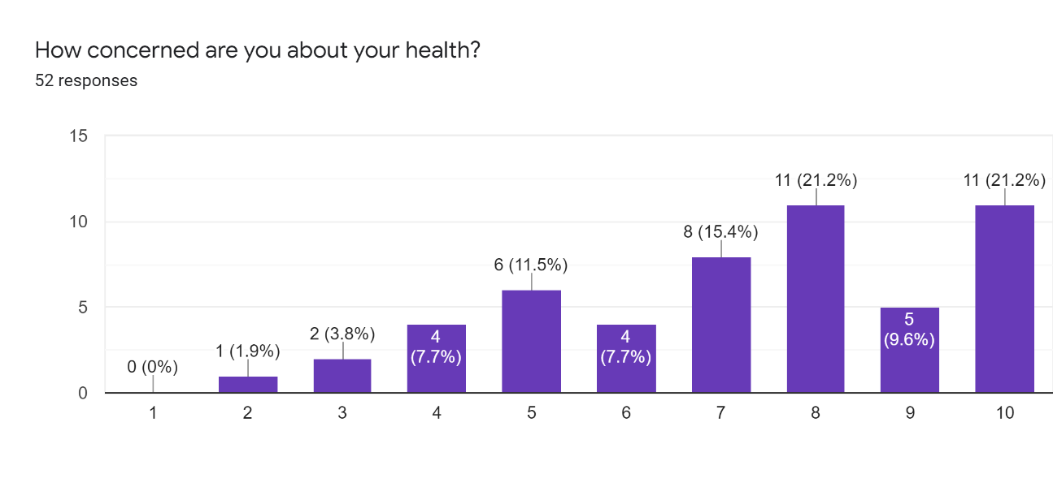
This survey was also designed to assess what the project should be focusing on and which health issues they would like to know more about. There were three clear leaders: menopause, spotting signs of cancer, and healthy eating (66.7%, 66.7% and 60.8% of women wanted to know more about these issues respectively). When asked how they would like to gain better access and confidence using services women highlighted that education and communication with these services were important to increasing accessibility.

What they did

Community Facilitator Model
The community facilitators were found through sharing job advertisements through BWV’s members network and the BWG. The project coordinator then gave them training on outreach and signposting to organisations. They started by conducting the initial survey and then their role transitioned to communications with the women involved in the project. After developing a plan with the project coordinator, they took on more responsibility for partnership with workshop facilitators and coordinating the volunteers who were assisting the project. As a result of the mid-way evaluation, it became clear that given the time constraints on the facilitators it was not feasible to run bubbles alongside the workshops, partnership development and setting up a gardening group. Once the larger group had been created, Khairun Miah took on the responsibility of organising and facilitating workshops whereas Lily Khander focused on the gardening group.

Workshops
Process:
Based on the initial survey the workshops focused on the issues that women had raised most frequently as areas they wanted to learn more about. The project coordinator and the community facilitators reached out to external organisations and asked them to facilitate or share their workshops with the women in the group.
Outputs:
The community facilitators organised a total of 12 workshops and facilitated access to a further 7 with the Bangladeshi Mental Health Forum in Tower Hamlet. The workshops ran specifically for the project are as follows, those shaded in light blue ran two workshops:
Name of organisation | Focus of workshop | No. of Attendees
Bristol Menopause | Menopause | 21
Sirona | Emotional Wellbeing | 15
CoppaFeel | Breast Cancer Awareness | 23
Brisdoc | 111 Services | 5
Brisdoc | Diabetes | 7
Mothers4Mothers | Parenting | 8
Rockabye | Post + Ante Natal Wellbeing | 4
Khairun Miah | Parenting | 16

The workshops ran by the Bangladeshi Mental Health Forum were not run specifically for the project but were found by one of the facilitators and women were encouraged to attend. As these workshops were run by a different organisation and many of the women changed their names on the screen, numbers are not exact and are based on their answers in the evaluation form or if a community facilitator was in attendance:

Name of workshop | Rough number of attendees
Mental wellbeing | 12
Young people and SUPP children | 7
Managing worry | 4
Learning disabilities and mental health | 6
Overcoming low mood and motivation | 4
Signposting and information services | 3
Eating disorders | 0

WhatsApp Group and Resource Library
Process:
The purpose of the WhatsApp chat was twofold, firstly to provide a place in which women could socialise and make connections with other women in the group and secondly as a place to share information about a variety of health issues. Initially, in order to create a self-help community for health issues and to ensure that women felt comfortable speaking about how *****
Initially the project coordinator and the community facilitators attempted to use peer mentors. However, while the women who attended the training had a positive experience, it then became too difficult to monitor the information that was being shared with their ‘bubbles’ alongside running workshops and building a resource library. Furthermore, there was some confusion about how to become a mentor, and what information they should be sharing, and the community facilitators and the representative from the Bangladeshi Women’s Group were struggling to conduct monitoring and evaluation, particularly given that many women had either limited English or technological capacities. The mid-way evaluation revealed that this was not an effective model for the project and a result of this one large WhatsApp group was made to share health information, which proved much more effective.
Outputs:
23 women attended the peer mentor training at the beginning of the project and created bubbles with which to share information.
After the larger group was created 49 women became part of the WhatsApp chat, and are directly receiving messages about health issues, support and sharing experiences with other women in their community.
The resource library can be found here: Bangladeshi Women’s Health Project - Bristol Women's Voice (bristolwomensvoice.org.uk)

Gardening Club
Process:
During the project planning stage, it was mentioned a few times by the women in the Bangladeshi Women’s Group and by other women in the community that they were interested in gardening as a form of exercise and relaxation. Initially, BWV organised sessions at St Werburgh’s City Farm, but found that women were not signing up due to distance, schedules and a lack of motivation.
However, during the March mid-way evaluation the at home gardening club was set up by Lily one of the community facilitators.
Outputs:
The drive for donations was extremely successful and 17 women received ‘vegetable starter’ gardening at home kits. They started an additional WhatsApp group with the women who received kits and anyone else who wanted to join. 10 of the women were already in the main WhatsApp chat but 7 were only members of that group. The group was of mixed ability, some being avid gardeners with others being total beginners.

Celebration Picnic
The celebration picnic, the only in-person event featured block printing, refreshments, an opportunity to meet face-to-face and for the women to celebrate their achievements and involvement in the project. 13 women attended with 11 children.

Partnership with Bangladeshi Women’s Group
The partnership with the Bangladeshi Women’s Group was critical to the project’s success. It got off to a slow start due to some miscommunication about a funding bid, and it took the project coordinator some time to get them invested in the project. However, as the project went on and Asma Qadar the director of BWG had more contact with the community facilitators and the director of BWV, the partnership became strong and both organisations did everything in their power to ensure that the project succeeded. When Asma was asked to identify why she felt the partnership had been successful she answered:
“It went well because we have worked with them before and spoken with them before. Ladies who were employed were good as well.”
This demonstrates the importance of the community facilitator model as it grounded the project in the community. It also highlights the necessity for BWV to continue to build relationships and trust with anchor organisations as without previous projects such as Women of Lawrence Hill and the City Listening Project, BWG may not have been committed to the project.
Role of Bristol Women’s Voice
When thinking about the role of BWV throughout this project staff, participants and workshop facilitators were clear that BWV acting as an intermediary between both funders and healthcare organisations was valuable to the project’s success. Furthermore, when asked if the project should have been run by an organisation specifically for Bangladeshi women, Khairun answered:
“I am not just a Bangladeshi woman, I am also a Bristol woman, and Bristol Women’s Voice is an organisation that I want to be a part of.”

What difference did the BWHP make

Methodology
To assess the impact this project had the evaluation report includes mixed methodologies. To evaluate how the women's health has been affected, and how they found their experience of being involved, a survey was shared that could be answered in paper form at the picnic, online or via WhatsApp. There were 16 responses out of the 56 women in both WhatsApp groups, so in addition information from the WhatsApp chat was used to get feedback from the workshops and analysed the chat in order to understand how information had been shared and the impact that had had on participants lives. Furthermore, 2 women were spoken to as case studies and a further 3 were interviewed at the celebration picnic.
Interviews were also conducted with the staff from BWV, the director of the Bangladeshi Women’s Group and workshop facilitators to understand how the organisations interacted and to gain a holistic overview of how the project worked.

Demographics
All the women surveyed and interviewed were between the ages of 35-64, and although there is anecdotal evidence to suggest that older women were being told the health information through word of mouth, feedback suggests that as the project had to be almost entirely online elderly women were not successfully reached. Future projects should investigate engaging women who are digitally isolated and at examining health issues that are relevant to elderly Bangladeshi women. All the women had two or more children, 81% were married and 19% were divorced. 38% of those surveyed had either gotten married or had children in Bangladesh, demonstrating that the project was reaching women with different cultural and health needs.

Midway evaluation
BWV attempted to carry out monthly assessments but due to all the activities being online and the mixed level of technological capacities, this proved ineffective and too time consuming for the community facilitators. Instead, a mid-way evaluation was conducted by one of the BWV volunteers with assistance from the director and the community facilitators. This included a survey and interviews with key stakeholders.
The survey demonstrated that WhatsApp was the best way to communicate with women and that the majority of women who were attending workshops were coming to multiple, with 46.2% attending 5 or more before the end of March.
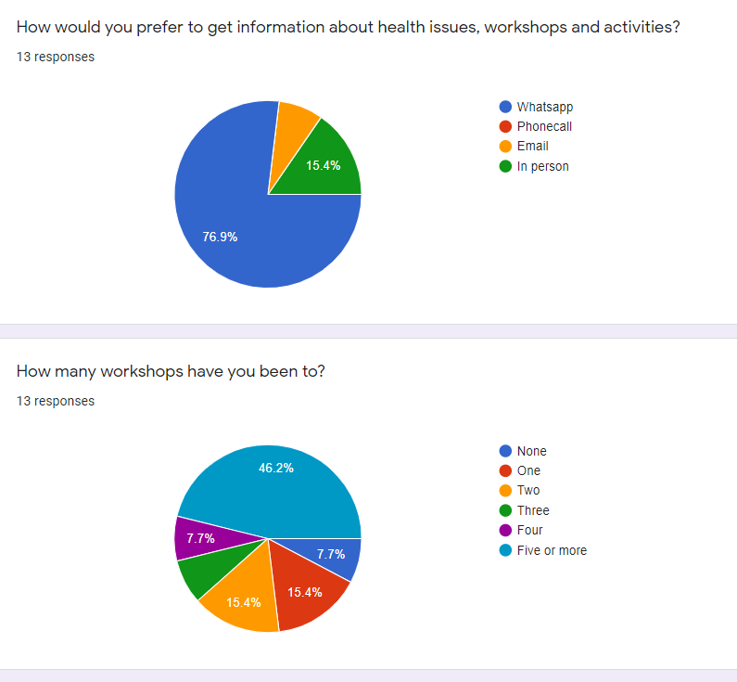
However, the midway evaluation highlighted that the bubbles were putting too much pressure on the community facilitators and the director of the BWG, and it was proving too difficult to monitor the information that was being passed on to bubble members, so as a result one big WhatsApp group was created. The use of WhatsApp was identified as extremely positive:
“WhatsApp has been crucial as a positive action. That has been a game-changer, and how the project was delivered, how the information was shared.”
The midway evaluation also highlighted those women who were not being reached due to language issues and digital barriers. As a result of this, Khairun reached out to the Bangladeshi Mental Health Forum who provided workshops in Bengali and women could attend the sessions they put on, as there was not enough budget for translation of all the workshops BWV put on. It also highlighted that Bangladeshi women are not a homogenous group, and have different cultural expectations around weight, appearances and cultural conservatism. Thus, workshops on healthy eating may not always be effective, but directing women to the cooking classes put on by the BWG may be a more effective way at engaging women with a wider variety of healthy recipes.

Community Facilitator Model
This was a pilot project for BWV, using the community facilitators who were integral to the project’s success. The two women who were hired as facilitators, Lily and Khairun, were of different ages, from different areas of the city and had had vastly different life experiences, which they both felt contributed to why they worked well together. Furthermore, they were not part of the Bangladeshi Women’s Group which meant that their outreach was reaching different women, allowing the project to engage Bangladeshi women who might not usually attend workshops put on by either BWV or the BWG.
“It was quite fantastically done, going through the networks. Bringing all of the networks together was well done and got the women engaged.” (Volunteer)
Furthermore, the community facilitators themselves also felt that they gained confidence, experience and social connections through being involved. Both facilitators have gone on to find other work related to health, and Khairun has been offered a role at Mothers4Mothers, directly because of the work she undertook throughout this project. She said:
“I gained so much from this project, learnt a lot in terms of communication and connected with external agencies and people, arranging the sessions. I’d never even used zoom before and have now been delivering sessions to my own communities. Lots of opportunities came up from this as well, and it has aided me in my job. I really enjoyed being part of the project.”
The other community facilitator, Lily, also spoke about how the project had helped to lift her out of a period of low-mood and isolation as well as connecting her with other organisations. Moreover, she felt re-connected to the Bangladeshi community:
“I have been surprised how much they have engaged, they have learnt and taken part. I have been surprised how much I have enjoyed it! I have enjoyed the whole journey."

Overall Outcomes
As a result of the information provided by the project 75% of women surveyed said they were more likely to seek medical help immediately for both physical and mental health issues. Women identified both the WhatsApp chat and the workshops as being key to their increased knowledge speaking about health issues:
“Lots of new information I didn’t know before” (Workshops)
(WhatsApp Group) “It helps us learn so many things and they give information”
When asked to rank how healthy they were feeling between 1-10, only 6% ranked themselves under 5, compared to 20% at the beginning of the project. This is a significant improvement, and external factors such as the weather and lifting of COVID restrictions will also have contributed. Furthermore, the second survey had less respondents so those who scored themselves under 5 may have not taken the second survey. Nonetheless, both the WhatsApp chat and interviews with the women suggests that the project has had an impact on their health and wellbeing:
“After 1 and half year I walked longest yesterday. Bit in pain but my mind is so relaxed.” (WhatsApp Group)

Workshop Outcomes
The workshops were extremely well received and showed clear signs of improving women’s knowledge of health issues as 100% of women who responded to the survey found the workshops useful. When asked why they found the workshops useful, women said that they had “learnt lots of new information” that they had not “previously been aware of”. There was also often discussion in the WhatsApp chat after each workshop, and women reflected on how the issues that came up impacted their own lives. Words to describe the workshops included “useful”, “informative” and “amazing”. In the evaluation form, two women also described how the workshops had given a sense of community as it was a (virtual) place to meet and support one another, demonstrating how the group has been used to build a network of women.
The workshops being online had some significant benefits. As put by Asma, director of the Bangladeshi Women’s Group:
“Online was better, this group has been running for 34 years and when you tell people about an event, everyone would be interested then when the day comes it didn’t work, they wouldn’t show up. Online they could just turn up and not show their face. It would have been nice to have face to face but it would have been hard face-to-face.”
This sentiment was also expressed at the celebration picnic as when asked about what they liked most about the workshops, they spoke about how useful it was that they could attend the workshops, listen and ask questions while still cooking or looking after the children at home. Therefore, had the workshops not been online the project may not have been able to reach these women.
The most popular workshop spoken about at the picnic was the menopause workshop run by Bristol Menopause. Women spoke about how they had previously had no knowledge about the possible symptoms that could come with menopause, and two women highlighted that they had been living with symptoms for over a year without knowing what they were. In the evaluation form they expressed a desire to learn more and have repeat workshops, showing a continued appetite for workshops and information. However, it should be noted that menopause is particularly relevant to the age group that was reached, but it may be necessary to cover other aspects of reproductive health that are relevant to younger and older women in order to engage with them.
Workshop facilitators feedback
Of the organisations that put sessions on specifically for the group, the facilitators all felt that they had been able to reach women that their organisation would otherwise have missed, which had a positive impact on their organisations:
“It was mutually beneficial as I learnt a huge amount about the community, we had an opportunity to talk about language we use when talking about pregnancy and post-natal mental health, which was an opportunity to check in the language we use is meaningful.” (Maria Viner, CEO, Mothers4Mothers)
Three of the four workshop facilitators spoken to as part of the evaluation also spoke about the role that the partnership between BWV and the BWG had to play in the success of their workshops as they felt that BWV gave them a sense of legitimacy, while BWG provided a way of reaching out to women they wouldn’t otherwise have reached. Two of the four spoke about how welcomed they had felt by both organisations, the facilitators, and the women themselves:
“I was a bit personally apprehensive because I am not a representative of their community, but I was made to feel really welcome and we ended up having really good discussion about asthma.” (Frank Burge, Head Of Nursing and AHP IUC, Brisdoc)
“Right from the beginning BWV enthusiastic and welcoming and being really invested in making it work, really generous in learning about each other. Felt very supportive, really enjoyed them and learning from them.” (Maria Viner, CEO, Mothers4Mothers)
Furthermore, because of engagement with the project, Brisdoc are looking to engage a Bangladeshi woman on the patient engagement board to further their understanding of the issues their community is facing, and two women from the group have sent off their CVs to be considered for the position. One of the community facilitators, Khairun, has also been offered a position at Mothers4Mothers (dependent on funding) as a peer support worker, demonstrating that this project has linked health organisations with the Bangladeshi community, making it easier to spread health information beyond the life of the project.
Shanaz Chowdhury from Sirona, a social enterprise focused on health and social care, also spoke of the benefit of having an easy way to share information with women after the sessions, as the WhatsApp group provided a way to communicate with women immediately after the sessions and signpost to other organisations.

WhatsApp Chat Outcomes
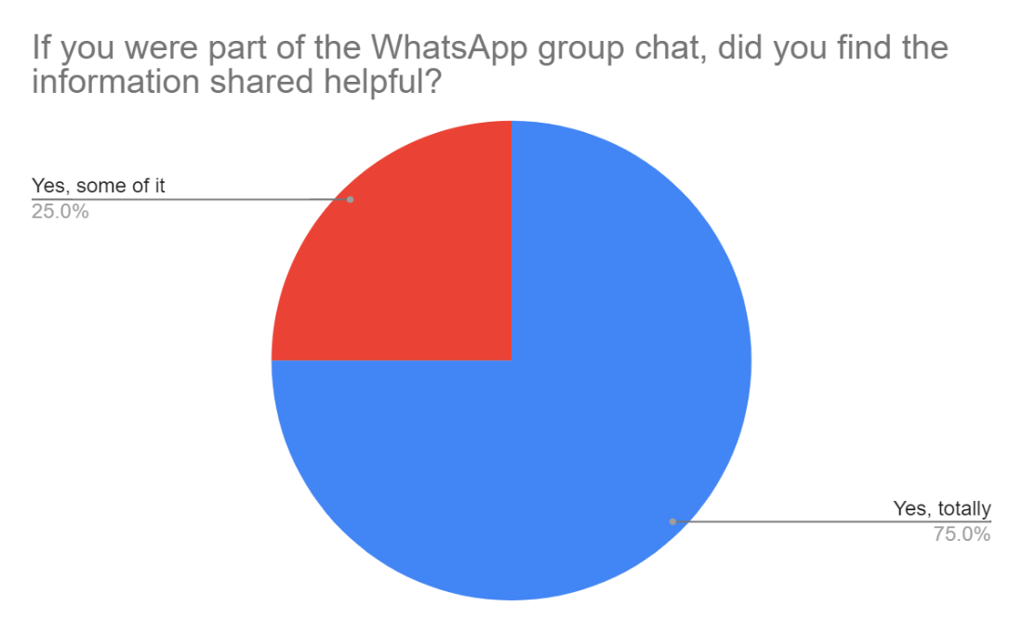
100% of women surveyed said they found the information shared on the WhatsApp chat helpful because it was “relevant” to the issues that they were facing. When asked which issues in particular they felt were most useful to them, menopause was the most common response, including one woman who has started taking B12 as a result of the information provided in the project. The other topics mentioned reflected the target areas highlighted by the initial survey: mental health and breast cancer awareness. This demonstrates the importance of grounding the work in the initial consultation with women through the community facilitators. Parenting was also raised as one of the issues they felt they had found useful, as one of the facilitators, Khairun, had drawn on her skills as a family support worker. This was an area that women found useful and relevant but also wanted to know more.
Previous projects have struggled with low engagement from Bangladeshi women, and it was clear from the evaluation form that one of the reasons this project was so successful was that the WhatsApp group enabled them to participate in the project even if their schedules and commitments meant they couldn’t attend workshops. They still felt that they were being kept up to date on the information being shared. These quotes demonstrate this:
“It was great because we didn't have to visit.”
“You are up to date with the programme, sharing others views and can also share my experience.”
Furthermore, as highlighted by the second quote, it allowed women to share their experiences and support one another with health issues they are facing. This demonstrates how the project not only spread crucial health messages but also provided Bangladeshi women with a space they felt comfortable speaking about these issues:
“We could share our thoughts”
An unexpected outcome of the WhatsApp group was the spreading of information about COVID-19 vaccines. This included sharing links to sign-up, myth-busting and sharing their experiences of common side effects. One woman shared that without the group she would not have gotten the vaccine. Furthermore, the information and myth-busting has spread to other family members:
“Member of the WhatsApp group, she was saying that her greater family parents and aunts weren’t in favour of the vaccine but as part of the project she shared vaccine information amongst greater groups and beyond the project. She shared the information with extended family and as a result got the vaccine. Her father was adamant not to have it, but had his mind changed.” (Lily, Community Facilitator)
Furthermore, although the bubble model did not work effectively in this project, it has gone on to be used in the ‘COVID Keep in Contact’ project:
“This project has very much been the model we employed in the covid keep in contact project. When asking what we can do as an organisation, we felt we had a role in reducing women’s isolation because of childcare and illness, and so far it has been successful.” (Katy Taylor, Director BWV)
In terms of sustainability of the project, the WhatsApp group is likely to continue without any further input from BWV. At the time of writing, the project has finished over a week ago and there are still posts about vaccines, fishing trips and BME mental health workshops. Furthermore, women from the BWG have started to facilitate their own workshops surrounding autism in children because of discussions in this project, demonstrating the increased level of confidence and support.

Gardening Project Outcomes
The success of the drive for donations meant that there was a surplus of gardening materials that could be shared with other organisations such as Mothers4Mothers and the Chinese Women’s Group. The volume of donations also demonstrated collective action of women across the city and both the director of BWV and BWG commented on the feelings of support that the donations created.
Moreover, as the gardening project WhatsApp chat was of a slightly smaller group, one of the volunteer’s noted that women were far more open than they were in the larger group and that women who were largely silent on the bigger group felt more comfortable sharing their personal experiences. A facilitator commented that:
“There is good participation, women are still active and watching. Women have been encouraging one another, and a mixture of abilities joined in. I think the group will survive quite happily.” (Lily, Community Facilitator).
Women also commented on the group that enabled them to feel more relaxed (aside from the slug decimation this year!) and provided a way of interacting with other Bangladeshi women that they may not otherwise have met.
The gardening group has been enormously successful, with women who have no gardening experience successfully growing vegetables and sharing their experiences with other women, which has contributed to greater social networks and reduced isolation.

Case Study
A woman - MU - was a Bangladeshi born woman who came to the UK after she was married, she had two children, both aged under ten. She was recruited as a bubble member by one of the community facilitators - she was a friend of a friend and wasn't connected to the Bangladeshi Women's Group and didn't know many women from the Bangladeshi community outside her small family unit. Her English was sufficient to understand but she finds it difficult to explain things in English. She was lonely.
She has been an active attendee from the beginning - attending most of the workshops, particularly the ones around mental health, she signed up for the gardening project and has regularly inputted pictures of her growing vegetables. MU said (with a community facilitator help):
"I have really enjoyed the project as I was able to learn about different issues and hear about the issues and problems faced by other women. I see that I am not alone - I am not the only one struggling. I have learnt how identify mental health issues - the signs to looks out for and where to go for help."

The pictures shared on the WhatsApp chat were often of the vegetables grown using the starter kits provided. Here are some examples of chillies, tomatoes, broccoli and runner beans:

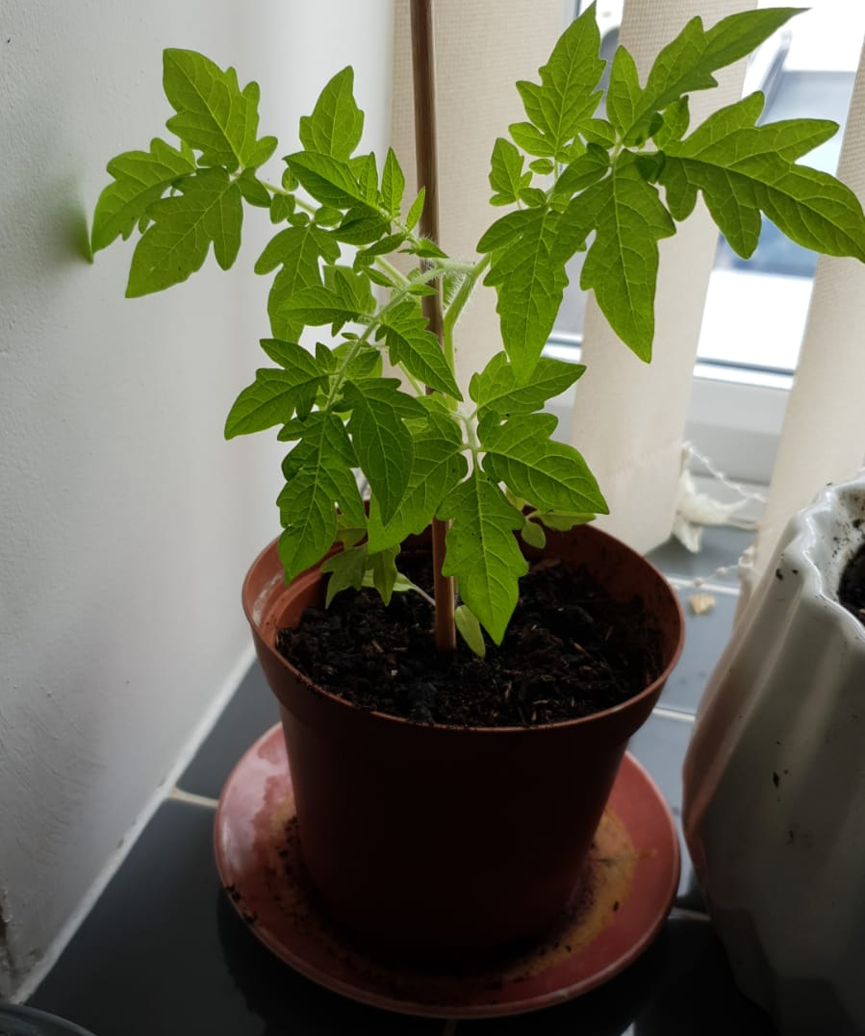
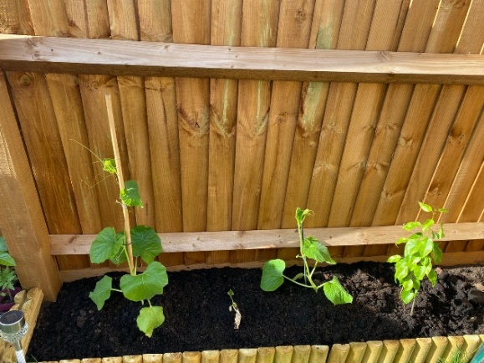
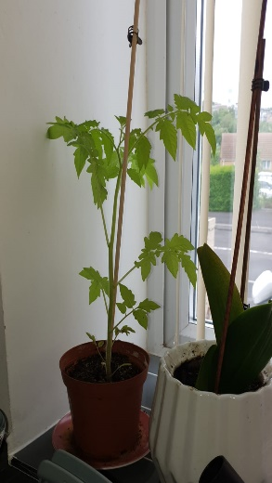
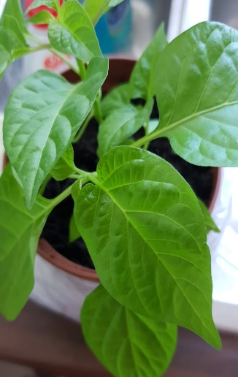
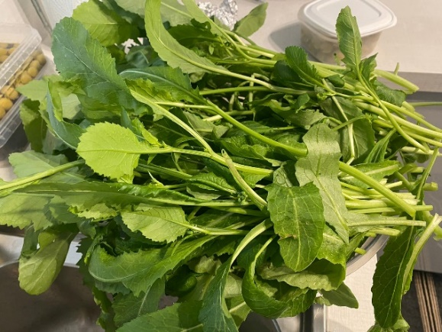
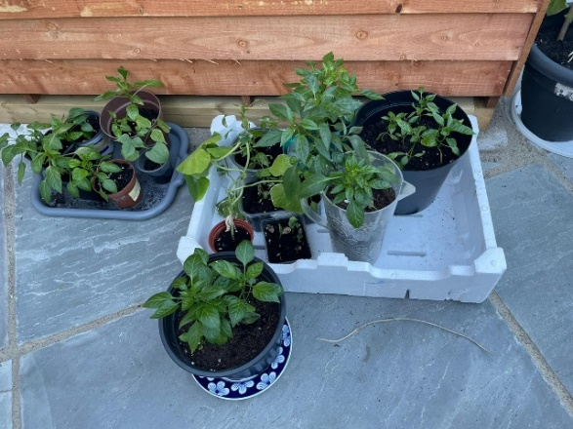

Celebration Picnic

The celebration picnic at the end of the project featured a block printing workshop and provided an opportunity to meet face-to-face and for the women to celebrate their achievements and involvement in the project. One of the community facilitators, Khairun, commented that many of the women who attended were new faces to her, demonstrating that the outreach has gone beyond the facilitators own social networks. The feedback from the WhatsApp chat was overwhelmingly positive:

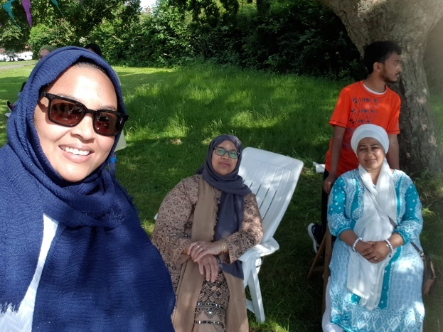
“Thanks for arranging this event. It was so lovely day and great to see everyone. Specially enjoyed the block printing and chitchat.”

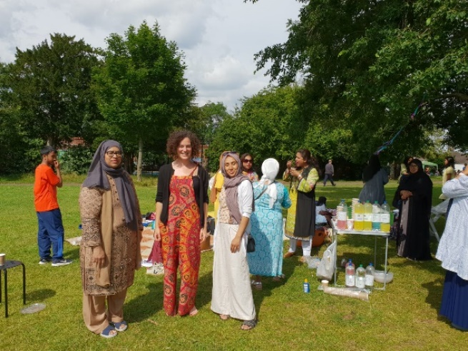

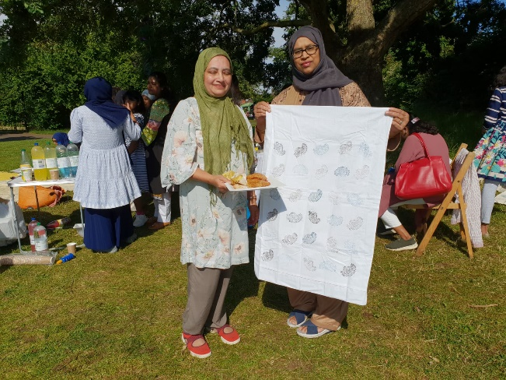

Challenges and changes
WhatsApp Group
Although the WhatsApp group was far more successful at putting out health messages and reaching women as a big group, it also meant that some women found they were less confident speaking about issues in a big group. Furthermore, as highlighted by the community facilitators, the Bangladeshi community in Bristol is tight knit, so they may have felt unable to speak about stigmatised issues such as mental or sexual health. This was highlighted by one of the participants:
“Our community doesn’t come forward, still health issues are stigmatised” (Interview)
Communication
Communication, particularly at the beginning of the project, was one of the main challenges the project faced. Once communication channels were opened, there were some issues, such as finding times that were suitable for everyone that did not clash with events run by the BWG. Khairun, a community facilitator made a calendar that helped to rectify this, but in future projects this should be done earlier as part of the project plan. Communication was also an issue through the bubble leaders as women were confused about what information should be shared or how. This was due to a lack of clarity about how to become a bubble leader alongside language, technological and time constraints. In future if running a similar model, there should be a dedicated staff member or volunteer who is solely responsible for bubbles, as the time constraint on the facilitators and director of BWG meant it was difficult to address the level of questions alongside monitoring what information was going where. Furthermore, there should be a clearer plan in place about how communications with both the women and partners would function and who is responsible.
Workshop facilitators
Although the majority of the workshop facilitators felt that being involved in the project was mutually beneficial, the Bangladeshi Mental Health Forum flagged that they had not been properly informed about the fact the project was funded and the nature of the project. They felt this prevented them from engaging on an organisational level and having the ability to fully benefit from the project. Although BWV did not get this feedback from any of their other partners, an error was made and it is critical that when engaging with other organisations clear communication is established. This is a crucial lesson to take forward as Bristol Women’s Voice engage with other organisations in future projects.
Language and Translation
One of the key limiting factors for engaging women was that many of the women had limited levels of English and while both of the facilitators spoke Bengali they were not confident translating health materials. Furthermore, there are two main dialects in Bristol, Bengali and Sylheti and translation would need to be in both dialects to fully ensure that Bangladeshi women in Bristol are supported.

Partnerships
Partnering with the Bangladeshi Women’s Group was crucial, however there were elements that could have been done better or earlier. One of the key reasons the project was slow starting was that there was miscommunication over who had got funding from whom, and if they had been more involved and kept in contact during the funding bid process this could have been avoided. The delay due to COVID-19 also had a role to play in the weakening of communication, but it is important to keep partners involved in the entire process to ensure they buy-in to the project and that BWV are able to co-produce projects effectively throughout.

Future areas for development
Reaching different age groups
Although the project was very successful at engaging Bangladeshi women, the age range was limited to 35-64. Future projects should consider reaching other age groups, particularly older woman as research by the BMJ along with Bristol based organisations have demonstrated that elderly Bangladeshi women are facing multiple chronic health issues. Due to the digital isolation that many elderly women face, a project that would be able to engage more face-to-face interaction may address this issue, alongside focusing on issues such as dementia, arthritis and chronic issues.
Hybrid model
As already mentioned, some aspects of the project being online were extremely beneficial. However, there was also a clear desire for more face-to-face interaction. The celebration picnic, the only in person event at the time of writing, enabled women to meet others in the project and spoke of the positive impact of socialising with women they had not previously met. A hybrid model of online and in-person workshops or events would hopefully allow women to participate around juggling work and childcare but more effectively tackle social isolation.
Workshops on other aspects of health
The appetite for more workshops was clear throughout the evaluation with 70% of women expressing a desire for more workshops when asked what they would like to see next. Some women wanted repeats of the sessions already run, but other areas were also flagged as needing attention. Sexual health, oral health, and caring for SEN children were all raised as issues they felt needed more coverage. Future projects could focus on these areas, alongside putting on workshops that are relevant to women outside of the demographic the BWHP were able to reach.
Peer Support
It is clear there is an appetite for more support to speak about women’s health issues amongst the women in the BWHP. It is also clear that there are still many issues that are stigmatised, and future projects should work on breaking down the stigma that surrounds mental health, sexual health and reproductive health while supporting women to speak about their own experiences. The peer support model may be more useful face to face, as women who are digitally excluded would be able to attend and doing peer support offline would not leave a ‘digital footprint’.

Recommendations
- The community facilitator model was clearly very effective both in terms of outreach and in improving the confidence of the facilitators themselves. This model should be used in other communities.
- Future partnerships with other organisations should start from the time of writing the funding bid, and clear channels of communication should be established throughout.
- The project plan should be developed by a steering group of women from within the community, to ensure that the project is co-produced and that the aims of each part of the project are clearly articulated in language that is meaningful to them.
- Outside of COVID-19, a hybrid model of online and face-to-face activities should be used, as the success of Bangladeshi women attending workshops they did not have to travel to, should not be overlooked.
- Future projects in the Bangladeshi community should look at translating more material and at putting on workshops that are in Sylheti as well as Bengali.
- BWV has a role in facilitating opportunities for women and health organisations that otherwise might seem inaccessible, and future projects should explore this further to ensure women are getting the opportunity to meaningfully engage with these organisations.

Conclusion
The BWHP hit most of its key objectives; 49 women are now part of the WhatsApp chat receiving direct health information, and as demonstrated by the midway evaluation, WhatsApp is the most useful format for the women involved. A further 7 are part of the gardening group. The WhatsApp chat is also being used by its members for self-help purposes, with women using the information provided and sharing opinions. 12 workshops were run over 6 months with 4-16 women attending each time with increased access to 8 workshops run in Bengali. Service providers who ran workshops have been able to share health information directly via the WhatsApp chat, as well as gaining understanding of the issues Bangladeshi women are facing and how to make their services more culturally appropriate.
The project also had unexpected added value as it led to myth-busting about the COVID-19 vaccine and as a direct result some members of the Bangladeshi community got the vaccination who otherwise would not have.
Both community facilitators have reported increase in skills and confidence, with Khairun going on to gain more employment as a direct result of work she did for this project.
As a result of these achievements, the BWHP was successful in improving the knowledge and confidence surrounding a variety of health issues for Bangladeshi women. The combination of the community facilitator model and partnership with the Bangladeshi Women’s Group was undoubtedly a key tenet in the project’s success, as it meant that women were reached regardless of their previous engagement with the community as demonstrated by the MU case study.
Furthermore, BWV also had a clear role as facilitating partnerships between health organisations and Bangladeshi women, and now the health organisations have a clear way of contacting women in the Bangladeshi community via the WhatsApp group. This project has been particularly successful in improving knowledge about menopause and parenting, however there are still a number of issues that need more work.
The key objectives the project missed was the train-the-trainer approach, in the form of peer mentoring. While it garnered a lot of initial interest was challenging to carry out and was ultimately found to be detracting from other areas of the project. It is difficult to know whether this would have been effective if elements had not been online, as the use of platforms such as zoom and keeping track of how the information was being used proved challenging. Future work should consider focusing solely on this aspect and dedicating a specific employee towards this.
In terms of monitoring and evaluation this was made significantly more challenging due to the project being online, as many of the women struggled to use online tools such as google forms and as the group could not meet up in person it was challenging to chase people up. As a result, there were some monitoring and evaluation opportunities were missed. However, the large WhatsApp group proved to be a real strength as it was not only far easier to track information, but women often responded with if and how they had used the information provided. Moreover, the success of the celebration picnic has highlighted how a hybrid model of online/offline activities could work in future as it solidified the social connections women had made online.

References
McKeigue PM, Marmot MG, Syndercombe-Court YD, et al.(1988) Diabetes, hyperinsulinaemia, and coronary risk factors in Bangladeshis in east London. Br Heart J 60:390–396.
McNally, S., 2015. Exercise: The miracle cure and the role of the doctor in promoting it. Academy of Medical Royal Colleges, London.
Raleigh, V. and Holmes, J. (17 February 2021) The health of people from minority backgrounds in England, Kingsfund, Last accessed 13/07/2020: The health of people from ethnic minority groups in England | The King's Fund (kingsfund.org.uk)

